MCLB ALBANY SAFETYGRAM
ERGONOMICS

Visit the following for more information.
Ergonomics
Industrial Ergonomics
Office Ergonomics

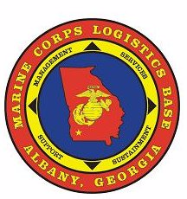
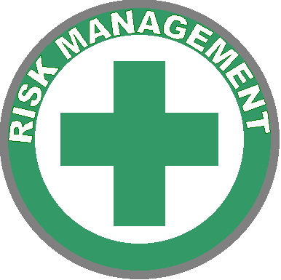
Risk Management Branch 639-5249

