MCLB ALBANY SAFETYGRAM
IS YOUR COMPUTER WORKSTATION OPTIMIZED FOR COMFORT AND EFFICIENCY?
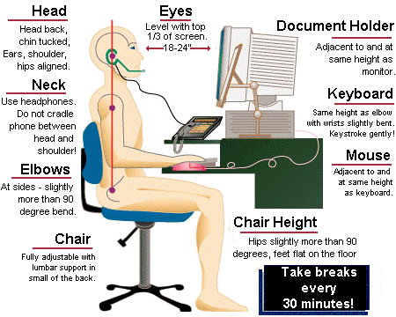
AAA


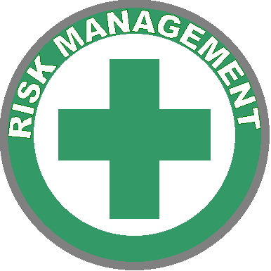
Risk Management Office 639-5249
Ergonomics Coordinator:
Donna Chalmers 639-6215
Visit the following resources for more information:
www.ergonomics.org

A “neutral” body position is the safest and most efficient position in which to work. Awkward posture puts stress on muscles, tendons, and joints that could lead to ergonomic disorders.

