HOW DO YOU DO BUSINESS?

MCLB ALBANY SAFETYGRAM
THE WRONG WAY or THE RIGHT WAY

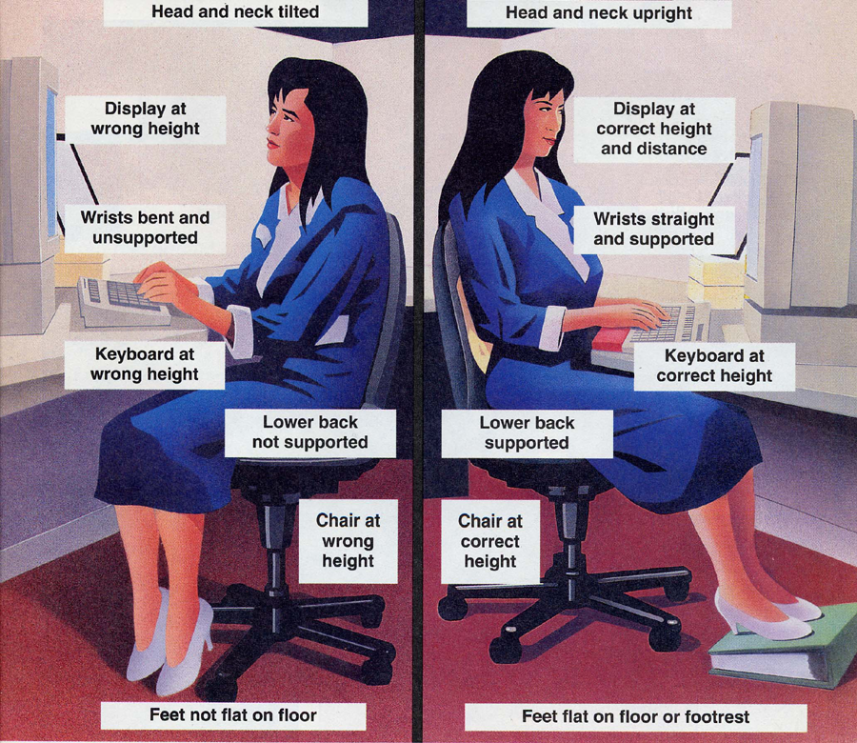
Regardless of your posture, sitting still for prolonged periods can cause fatigue and stress on your body. You should change your working position frequently throughout the day by making small adjustment to your chair; stretch your fingers, hands, arms and torso; and stand up and walk around for a few minutes periodically.
Visit the following resources for more information:
www.ergonomics.org




Risk Management Office 639-5249
Ergonomics Coordinator:
Donna Chalmers 639-6215

06 Sep 06
THE WRONG WAY or THE CORRECT WAY

